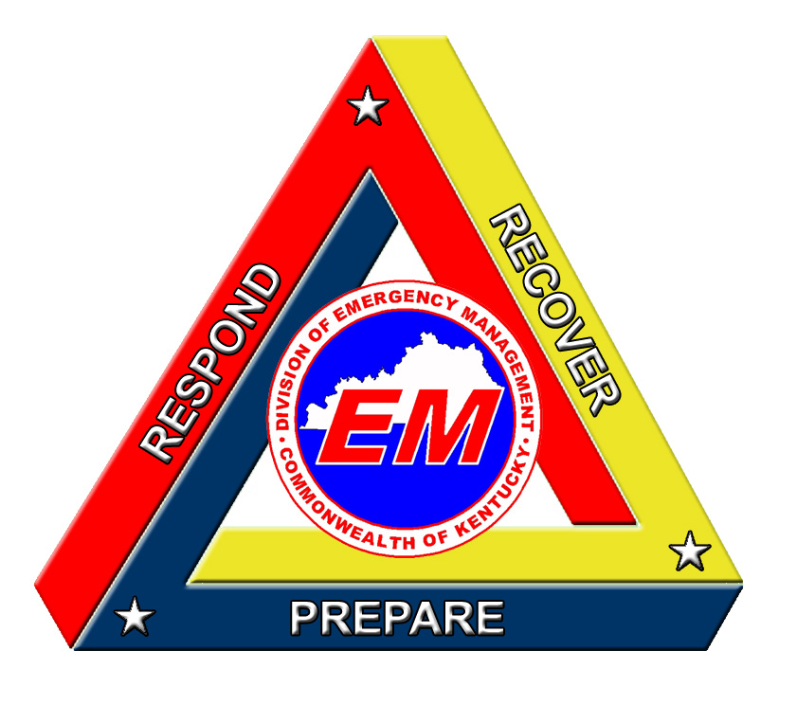
Public Service Announcement
Home Fire Safety Checklist Insert Photo Here
Provided by your
Local Emergency Management Office

Steps to prevent fires:
- Have properly working smoke alarms.
- Test smoke alarms and carbon monoxide detectors monthly and change the batteries at least once a year.
- Place smoke alarms on each floor of your home and in each bedroom.
- Plan a family escape route and practice it once a month.
- Install a home sprinkler system.
- Place fire extinguishers throughout your home and make sure everyone in the house knows how to use them.
Is your home free of hazards?
- Check electrical appliances for loose or frayed cords. Do not place wires under rugs.
- Check for outlets overloaded with plugs; including TV, computer, stereo, and printer.
- Install GFCI (ground fault circuit interrupter) outlets in your home; especially near sources of water like your bathroom, kitchen and laundry room.
- Use the correct bulb wattage for home light fixtures.
- If any appliances spark, smell unusual or overheat, replace or get repaired by a professional.
- Lamps and nightlights should not touch any fabrics (bedspreads, drapes).
- Electrical blankets are unplugged when not in use. Check for frayed or loose cords and any odd smell. If a problem is detected, replace.
- Supervise children around the stove and microwave.
- Candles should be out of reach of children and pets, curtains and furniture. Never leave candles unattended.
- Annual inspection of furnace or heating system
- Space heaters:
Keep out of walking paths.
Keep away from children and pets.
Placed away from beds.
Newspapers, magazines, and any fabrics, including curtains, sheets, tablecloths, are not within three feet of a space heater.
Unplug when not in use.
- In the kitchen
Keep an eye on appliances when in use.
Make sure appliances are turned off and unplugged when not in use.
Using pots and pans, use rear burners and turn the handles inwards.
Do not wear loose clothing while cooking.
- Fireplaces
Keep the fire place clean.
Cover your fireplace with a screen.
Only burn wood. Papers and other materials can escape while burning and ignite something nearby.
The fire should be completely extinguished before leaving the room.
Have your chimney cleaned professionally once a year.

